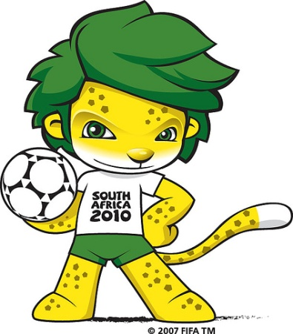
Our World Cup Country Is……………….

Names of students in our group: 1.
2.
3.
4.
5.

What our presentation will involve: (eg costume, Moviemaker, flags, food, song, etc,)
________________________________________________________________________________________________
________________________________________________________________________________________________

Allocation of tasks:

Name | Job

Resources required & how we will organise them:
________________________________________________________________________________________________
________________________________________________________________________________________________
________________________________________________________________________________________________

